

**Excel Assignment - 16**

1. What is a Macro? How is it useful in excel or in your daily work?

* In computing and programming, a macro is a series of instructions or commands that are grouped together and can be executed with a single command or user action. In the context of Excel or other spreadsheet software, a macro refers to a set of recorded actions that automate repetitive tasks or perform complex operations. Macros are written in a scripting language called VBA (Visual Basic for Applications) in Excel.
* Here's how macros can be useful in Excel and daily work:
* Automation of Repetitive Tasks: Macros can be used to automate repetitive tasks that you often perform in Excel, such as formatting data, applying formulas, or generating reports. Instead of doing these steps manually each time, you can record a macro once and replay it whenever needed.
* Time-Saving: By automating tasks, macros can significantly save time and improve productivity. For example, if you have to apply the same set of calculations to multiple datasets, a macro can perform these calculations with just a few clicks.
* Error Reduction: When you perform repetitive tasks manually, there is a higher chance of making mistakes. Macros can follow a predefined set of instructions, reducing the possibility of errors in data processing.
* Complex Data Manipulation: Macros can handle large datasets and perform complex data manipulation operations more efficiently than doing it manually. This is especially helpful when dealing with thousands of rows or more.
* Custom Functionality: With macros, you can create custom functions that are not available in Excel by default. These functions can extend Excel's capabilities and help you solve specific problems.
* Consistency: Macros ensure consistency in data processing, formatting, and analysis across different workbooks or sheets, as they follow a standardized set of instructions.
* Task Integration: Macros can integrate with other applications, allowing you to automate tasks that involve interactions between Excel and other software.
* Dashboards and Reporting: Macros can be used to create dynamic dashboards and reports that update automatically when data changes, providing real-time insights.

1. What is VBA? Write its full form and briefly explain why VBA is used in excel?

- VBA stands for "Visual Basic for Applications." It is a programming language developed by Microsoft and integrated into various Microsoft Office applications, including Excel, Word, PowerPoint, and Access. VBA allows users to create and automate custom tasks, functions, and interactions within these Office applications.

In Excel, VBA is used to extend the functionality of the spreadsheet software beyond what is provided by built-in functions and features. Here are some reasons why VBA is commonly used in Excel:

Automation: VBA enables users to automate repetitive tasks, such as data manipulation, formatting, and report generation. This automation saves time and reduces the likelihood of errors in data processing.

Custom Functions: With VBA, users can create custom functions, also known as User-Defined Functions (UDFs). These functions can perform specific calculations or operations tailored to the user's requirements, providing added flexibility in data analysis.

Interaction with Other Applications: VBA allows Excel to interact with other Microsoft Office applications and external data sources. This feature enables data exchange, importing/exporting data, and automating processes that involve multiple software tools.

Complex Data Analysis: VBA enables users to perform complex data analysis and modeling, which may not be achievable through Excel's standard features. This capability is particularly useful for advanced statistical analysis and specialized calculations.

User Forms and Dashboards: VBA facilitates the creation of custom user forms and interactive dashboards in Excel. These customized interfaces allow users to input data conveniently and view results in a user-friendly manner.

Report Generation: VBA can be used to automate the creation of customized reports with specific layouts, designs, and data formatting.

Data Validation and Error Handling: With VBA, users can implement data validation rules and error-handling mechanisms to ensure data integrity and accuracy.

Process Integration: VBA allows Excel to integrate with external systems, databases, and APIs, making it possible to automate data retrieval and update processes.

In summary, VBA is used in Excel to extend its capabilities, automate tasks, create custom functions and forms, and integrate Excel with other applications and data sources, thereby enhancing productivity and enabling users to perform more advanced and tailored data analysis and manipulation

1. How do you record a macro? Write detailed steps to create a macro to automatically make the following table in bold and to create borders for it in excel.

hi 78 hello 69 ineuron 45

* Open the Excel workbook that contains the table you want to format.
* Click on the Developer tab.
* In the Code section, click on Record Macro.
* In the Macro name box, enter a name for your macro. For example, you could enter MakeTableBoldAndBorder.
* In the Shortcut key box, you can enter a shortcut key to run the macro. For example, you could enter Ctrl+Alt+B.
* In the Description box, you can enter a description of what the macro does.
* Click on OK to start recording.
* Select the cells that you want to format. In this case, you would select the range A1:C3.
* Click on the Bold button on the Home tab.
* Click on the Borders button on the Home tab.
* Select the border style that you want to use. In this case, you could select the All Borders option.
* Click on Stop Recording.
* Now, you can run the macro by pressing the shortcut key that you specified, or by selecting the macro from the Macros dialog box.

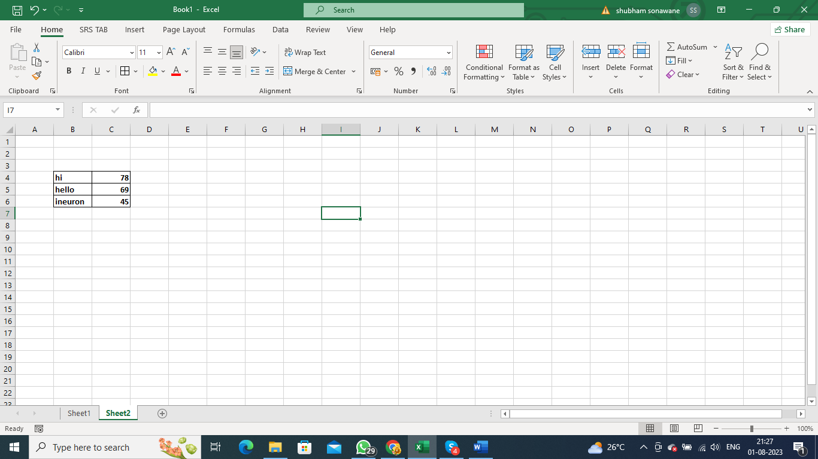

1. What do you mean when we say VBA Editor?

* When we say "VBA Editor," we are referring to the integrated development environment (IDE) provided within Microsoft Excel (and other Microsoft Office applications) for writing, editing, and managing Visual Basic for Applications (VBA) code.
* The VBA Editor allows users to create, modify, and debug VBA code that extends the functionality of Excel and automates various tasks. To access the VBA Editor in Excel, you can use one of the following methods:
* ALT+F11 Shortcut: Pressing "ALT" and "F11" keys simultaneously opens the VBA Editor.
* Developer Tab: If the Developer tab is visible in the Excel ribbon, you can click on it and then click "Visual Basic" to open the VBA Editor.
* Once inside the VBA Editor, you will see a window that consists of several components:
* Project Explorer: This window displays the list of open workbooks (Excel files) and their corresponding VBA projects. Each workbook contains a VBA project that can contain modules, forms, and other objects.
* Code Window: This is the main area where you write and edit VBA code. You can create or open modules, class modules, and user forms here.
* Immediate Window: This window allows you to execute VBA code interactively. You can test individual lines of code or view the output of specific commands.
* Properties Window: When you select a VBA object (e.g., a form or a control), the Properties window displays the properties associated with that object. You can modify these properties to customize the behavior and appearance of the object.
* Immediate Pane: This pane allows you to see the output of code execution or messages during debugging.
* Using the VBA Editor, you can write VBA code to create custom functions, automate tasks, build user forms, and interact with Excel and other Office applications. It provides a powerful environment for developers and users to enhance Excel's capabilities and tailor solutions to specific needs. It is essential to be cautious while writing and running VBA code, as improper code execution can lead to errors or unintended consequences. Always ensure to save your workbooks before running VBA code and consider creating backups for added safety.

1. Briefly describe the interface of a VBA editor? What is properties window? And what is watch window? How do you display these windows?

* The VBA Editor interface consists of several windows that provide a comprehensive environment for writing, editing, and managing VBA code. Here's a brief description of the main windows in the VBA Editor:
* Project Explorer: This window is located on the left side of the VBA Editor. It displays a hierarchical view of all open workbooks and their associated VBA projects. Each workbook has its own VBA project, which contains modules, forms, and other objects related to that workbook.
* Code Window: The code window is the main area in the VBA Editor where you write and edit VBA code. When you double-click on a module or form in the Project Explorer, the corresponding code window opens, allowing you to view and modify the VBA code for that particular module or form.
* Immediate Window: The Immediate window is used for interactive debugging and execution of VBA code. It allows you to run individual lines of code or view the output of specific commands. You can also use the Immediate window to debug your code by printing variable values or executing specific statements during runtime.
* Properties Window: The Properties window is used to view and modify the properties of VBA objects, such as forms, controls, or modules. When you select a particular object in the VBA Editor (e.g., a form or a control), the Properties window displays a list of properties associated with that object. You can change these properties to customize the behavior and appearance of the object.
* Watch Window: The Watch window allows you to monitor the values of specific variables or expressions during debugging. You can add variables or expressions to the Watch window, and as you step through your code during debugging, the Watch window displays the current values of these variables or expressions.
* To display these windows in the VBA Editor:
* Project Explorer: The Project Explorer is usually displayed by default on the left side of the VBA Editor. If it's not visible, you can show it by pressing "CTRL+R" or by clicking "View" in the VBA Editor menu and selecting "Project Explorer."
* Code Window: To open a code window for a particular module or form, double-click on that module or form in the Project Explorer, and the corresponding code window will appear.
* Immediate Window: You can open the Immediate window by pressing "CTRL+G" or by clicking "View" in the VBA Editor menu and selecting "Immediate Window."
* Properties Window: To display the Properties window, click "View" in the VBA Editor menu and select "Properties Window." Alternatively, you can press "F4" to open the Properties window.
* Watch Window: To open the Watch window, click "View" in the VBA Editor menu, select "Watch Window," and then click "Add Watch..." or press "CTRL+W."
* Using these windows, you can efficiently write, debug, and manage VBA code in the VBA Editor to create custom Excel solutions and automate tasks.

1. What is an immediate Window and what is it used for?

* The Immediate Window is a feature in the Visual Basic for Applications (VBA) Editor of Microsoft Excel (and other Microsoft Office applications) that allows you to interactively execute VBA code and view immediate results. It serves as a powerful tool for debugging, testing, and inspecting variables or expressions during runtime.
* Here's what the Immediate Window is used for:
* Interactive Debugging: During debugging, you can use the Immediate Window to execute specific lines of VBA code one by one, which can help identify and isolate issues in your code. By running code interactively, you can observe the immediate effects of each statement and pinpoint the exact location of errors.
* Evaluating Expressions: You can use the Immediate Window to evaluate and test VBA expressions. For example, you can perform calculations, manipulate strings, or test conditions directly in the Immediate Window without needing to write a full procedure or function.
* Printing Variable Values: While debugging, you can print the current values of variables to the Immediate Window. This feature helps you inspect variable states and track changes as your code executes, helping you better understand how your program behaves.
* Immediate Commands: The Immediate Window allows you to execute certain built-in commands that provide useful information during debugging. For instance, you can use "Debug.Print" to output text or variable values directly to the Immediate Window.
* Testing Functions: If you've defined custom functions (User-Defined Functions or UDFs), you can test them in the Immediate Window to verify their functionality and correctness.
* Quick Data Validation: If you want to check the validity of data or expressions quickly, you can use the Immediate Window to test them before incorporating them into your actual code.
* Using the Immediate Window effectively can significantly speed up the debugging process and enhance your understanding of how your VBA code works. It's a valuable tool for developers to inspect and experiment with code interactively, making it an essential part of the VBA development environment in Excel. To open the Immediate Window, press "CTRL+G" in the VBA Editor or click "View" in the VBA Editor menu and select "Immediate Window."